Nepal College of Information Technology
Unit Test
Fall 2013
Program : BE ELX Time : 2 hrs
Semester : (V) FM : 70
Subject : Signal & System PM : 35

- Candidates are requested to give their answer as far as practicable in their own words.
- The figure in the margin indicates the full marks
- Attempt ALL question
1a | Define the following signals with an example  - Periodic and Non periodic signals  - Odd and Even signal  - Energy and Power Signal  - Unit step signal | 7
b | Determine if the given signal is memoryless, causal, linear, time invariant. | 8
2a | Sketch the line spectrum of the following: | 7
b. | Obtain the Fourier series representation of following signal  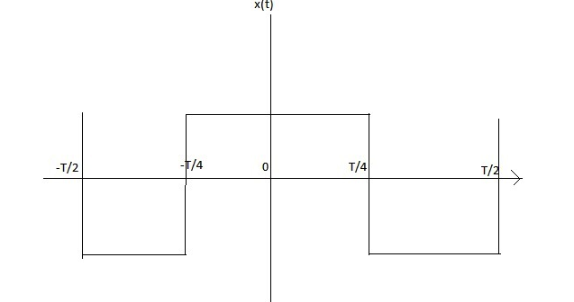 | 8
3  a | Determine the inverse Fourier transform of , also sketch the resulting spectrum | 7
b. | Find the Fourier transform of following Gausian pulse: | 8
4.  a. | Use any one method and perform linear convolution of given two signals: | 7
b. | Verify Parseval’s Energy Theorem for the given signal | 8
5. | Short Notes (Any two)  - Continuous and Discrete time signals  - Paley Wiener Criterion  - Auto-correlation and Cross-correlation

